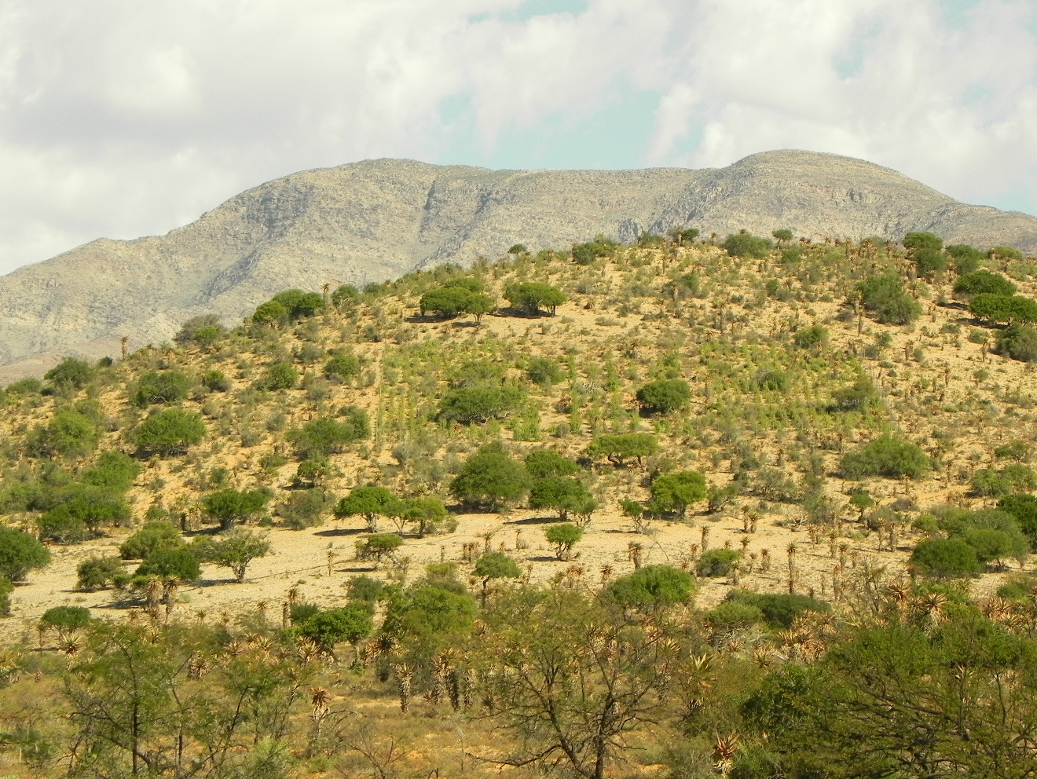

Draft 1: Standard Operating Procedure (SOP) for Carbon Baseline monitoring

(working document)

GEF5 SLM Project

Bolus C., Reeler J., Harris D., Powell M., Powell R. | Baviaanskloof | 2017/12/12

Table of Contents

List of Figures and Tables 1

Background 1

Monitoring groups 1

Selecting monitoring sites 1

Field sampling component 2

Data tracking 3

Plot demarcation 3

Fixed point photography 4

Litter sampling 4

Woody species sampling 5

*Euphorbia coerulescens* (Noors) sampling 8

Warehouse and laboratory component 9

Litter analysis 9

Labeling 9

litter samples 9

Plant samples 9

References 11

Annexures 12

Annex 1: cARBON bASELINE monitoring datasheets 12

12

# List of Figures and Tables

**Figure 1:** Litter collection is done using 50 x 50 cm quadrants. 5

**Figure 2:** Above ground woody species measured for height, canopy width and canopy length, on degraded lands on Tchnuganoo. 6

**Table 1**: A list of thicket species which have allometric equations based on their canopy height, length and breadth. The list is taken from data collected from Van der Vyver’s PhD work (2017). 7

**Table 2:** A list of thicket species which have allometric equations based on basal stem diameter from Powell (2009). 8

# Background

The following Standard Operating Procedure (SOP) is adapted from the STRP SOP (DEA, 2010a) used for monitoring in the Addo Baviaanskloof Fish River Restoration Program (ABFRP). This was part of project document (DEA, 2010b) developed for verification of the project through VCS (Verified Carbon Standard). The ABFRP is a Department of Environmental Affairs, Natural Resource Management (DEA-NRM) restoration program.

**Important Note:** This is a working document and is not the final document. It is being further refined based on the results obtained from the initial field experimental trial. Parts of the draft SOP which are verbatim from the original ABFRP SOP (DEA, 2010a) are highlighted in light blue as they have not yet been changed, whereas the rest is an addition or adaptation to this SOP. Notes are made about which parts of the SOP are likely to be changed, based on further expert input and the field trial results. Expert input was given by James Reeler, Dugal Harris, Mike Powell, Rebecca Powell and Cosman Bolus.

# Monitoring groups

At each site the following groups will be monitored:

1. Litter
2. Above ground biomass
3. Noors (*Euphorbia coerulescens*) coverage

The first 3 groups are measured in order to determine the amount of carbon, and are therefore termed “carbon pools”.

# Selecting monitoring sites

1. Using the required equations from the chosen methodology (page 46 of AR-AMS0002[1]), calculate the number of required monitoring plots per stratum. Stratification criteria include:
   1. Cohort (all plantings within a 5 year period are defined as a single cohort).
   2. Burn areas (areas that have undergone a burn will be assigned to a separate “burn stratum and monitored independently).
2. Initial calculations give a number of 10 sites for each stratum, and this is expanded to 15 to ensure redundancy in case of site damage or removal.
3. Within each sub-stratum (5 year planting plan), divide the number of monitoring plots by five to obtain the number of sites to be assigned to each planting year. Randomly assign any remainder amongst the planting years.
4. Using a GIS programme, determine random locations within the area designated for each planting year. This can be done using ArcView and the “Generate Random Points” tool from the freely available Hawth’s Tools scripts[2] or some other appropriate site-selection GIS algorithm. If an alternate method is used, this must be reported and documented. Assign the number of plots per area determined in step 2.
5. Assign each monitoring plot a permanent ID, using the following structure as an example:
   1. the first letter of the protected area (A = Addo, B = Baviaanskloof, G = Great Fish River);
   2. a two-digit number for the project instance within the protected area (01 for the first, 02 for the second, etc), followed by a period (.);
   3. a three-digit number for the number of the monitoring plot within the project instance.
6. An example of a plot ID is: **A1.21**, which means Darlington Dam area, of the Addo Elephant National Park, site 21.
7. Record the ID in the project database.
8. Once monitoring has been undertaken, review the means and standard error for each carbon pool within the stratum. If the standard error is greater than 10% of the mean at a 95% confidence level, additional monitoring sites must be assigned to each stratum. The number of sites can be calculated using the equations on page 46 of the methodology.
9. Current baseline monitoring sites are appended at the end of this document.

# Field sampling component

The recommended order of procedures for a given sites is as below. It is possible to deviate from this proposed order, especially if (for example) biodiversity is to be measured across all permanent monitoring sites, followed by the remaining criteria.

1. Plot demarcation.
2. Fixed point photography.
3. Aboveground biomass assessment (All woody and succulent tree and shrub species, and specifically spekboom and noors).
4. Litter monitoring.

Following this schedule minimizes the impacts of each procedure on the following procedure. Details of the processes are given below.

## Data tracking

A field inventory should be completed in order to ensure that no samples are lost between the field and the lab. Every time a sample is collected, register it in the field inventory. Store the field inventories with the data record sheets for the field site to allow for easy checking that all samples are present when the warehouse work is undertaken.

## Plot demarcation

For the plot demarcation, the major changes are as follows.

For degraded sites a 20 x 20 m plot will be setup to measure above ground woody species biomass. Litter quads of 50 x 50 cm in size will be setup 1m diagonally from the corners of the plot and outside the plot. A 5 x 5 m nested plot will be setup to measure all woody and succulent tree and shrub species dimensions , whereas for the rest of the plot only woody and succulent species >50 cm in height will be measured.

For intact sites, a 10 x 10 m plot will be setup to measure above ground woody species biomass. Litter quads of 50 x 50cm in size will be setup 1 x 1 m diagonally from the corners of the plot and outside the plot. A 5 x 5 m nested plot will be setup to measure all woody and succulent tree and shrub species dimensions , whereas for the rest of the plot only woody and succulent tree and shrub species >50 cm in height will be measured.

1. For each plot, four separate permanent markers will be placed. These comprise the four corner points of the 10 m x 10 m or 20 x 20 m plot .
2. Firstly, use the GPS coordinate specified to demarcate the southwest corner of the sampling plot. Drive an iron stake into the ground as a permanent marker. Iron stakes should be topped with a metal disc, and should be driven all the way into the ground to ensure that animals cannot injure themselves on the stakes.
3. Walk 10 m or 20m north depending on whether it is a degraded or intact site, and place a second marker. Each of the additional corner points can be placed by triangulation using either two tape measures or ropes of appropriate lengths. This will ensure that the plot is exactly 10 m x 10 m.
4. Alternatively, the four corner points can be accurately placed using a highly accurate (sub-50 cm) differential GPS device.
5. Should any of the corner points be impossible to place because they coincide with the location of a tree or large bush, the entire plot should be moved up to a metre in order to accommodate the points. Try to minimise the distance by with the plot is displaced.
6. Accurately record the locations of each of the corner points in the Site Record data sheet. Exact locations should be determined using a GPS device. Ensure that the locations are as accurate as possible.
7. The distance should be measured using a steel tape measure, and care should be taken to ensure that the line is as straight and level as possible. Use a steel pole to push the measure line through bushes and under trees that are inaccessible.
8. Once placed, all permanent markers should also be surrounded or covered with rocks, to assist in visibility and ensure that they are protected.

The biodiversity quadrants, soil plots (H1 - H6) and belt transects will not be used in the current SOP, as per the AFRP SOP.

## Fixed point photography

1. Fixed point photography should ideally be taken when the sun is high in the sky (i.e., not early morning or late afternoon) to ensure that the sun is not at an acute angle.
2. Set up a tripod at the south-western corner of the plot, ensuring that as much of the plot as possible is captured within the field of view of the camera. The tripod should be at least 1 m high.
3. If there is not a good view of the plot from the south-western point, move the camera up to 5 m away in order to capture a good proportion of the plot.
4. Take a photograph of the entire permanent plot. A digital copy of this image should be provided to the
5. With a GPS, record the location of the tripod to nine decimal places in the Site Record datasheet.

## Litter sampling

This part of the sampling will not be changed except that the location of the litter quads will be 1m diagonally away from the plot at each corner.

1. Locate a point 1 m from either edge of the plot, near the southwest corner (Figure 1c).
2. Place a 50 cm x 50 cm frame around this spot.
3. Collect all the litter (leaves, fruits, small wood ≤5 cm in diameter) falling inside the frame, and place it into a plastic bag. Do not remove growing vegetation.
4. Where the frame cuts across litter, include it in the litter measurement. This avoids the difficulty of attempting to measure fractions of litter components.
5. Repeat for each of the four corners of the permanent plot, combining the litter into a single sample.
6. Label the plastic bag appropriately (see “Label”), and include a second label inside the bag. Seal the bag and retain it for weighing at the warehouse.

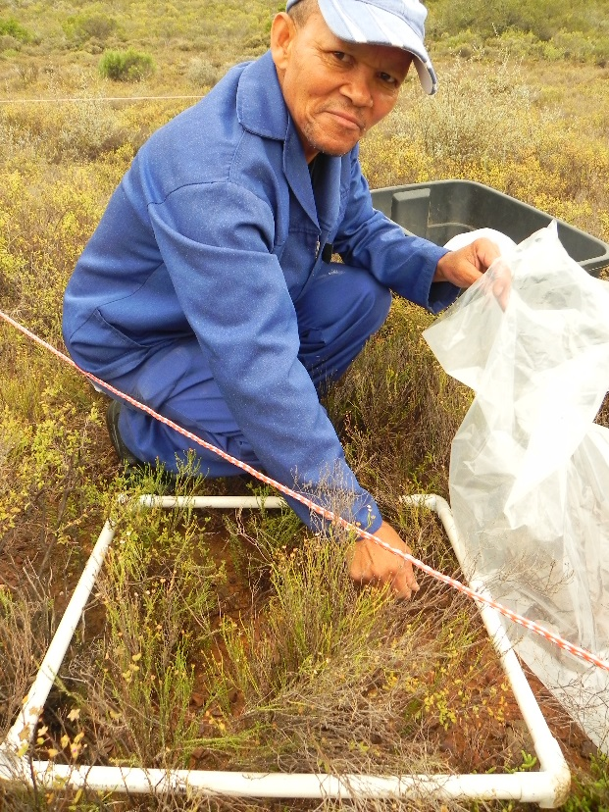

Figure 1: Litter collection is done using 50 x 50 cm quadrants..

## Woody species sampling

1. The initial sample includes all *woody* species plants within the 10 m x 10 m or 20x 20m permanent monitoring plot.
2. A 5 x 5 m nested plot will be setup to measure all woody species dimensions, whereas for the rest of the plot only woody species >50 cm in height will be measured.
3. Move from one side of the plot to the other, systematically measuring each canopy width and breadth of each plant as well as their height in the plot. Measure in cm.
4. For species which do not have good allometric relationships to canopy and height (see tables 1 & 2 below), measure the diameter of each stem with digital callipers at ground level. If it is not possible to measure the diameter at ground level, measure as close as possible to the ground.
5. Species which do not have an allometric equation allocated to them will be assigned the equation for the plant which is closest in growth form and genus.
6. For stems with a non-circular profile, measure the widest diameter at the base of the stem.
7. Record the diameter of the stem on the datasheet and assign it a plant number (all stems from the same plant should have the same number).
8. Assign each plant with its species name or labelling code if it cannot be identified in the field
9. Once a stem has been measured, mark it with a non-damaging marker (piece of thread, spot of paint, felt-tip marker, etc) to prevent the double-counting of stems.
10. Where the plant has a large fringe of stems growing from the ground, measure all the stems in the fringe, and then progress inwards. It is allowable to remove smaller stems in order to measure the larger stems, but try to avoid damaging the plant as much as possible.
11. Where two plants have fringes that are growing together, extend a rope between them at a point that you estimate is closest to the intersection of the two fringes. Assign all stems on the left to one plant, and all stems to the right to the other plant.

Variables to be recorded: diameter of all *P. afra* stems at ground level, plant number for each stem.

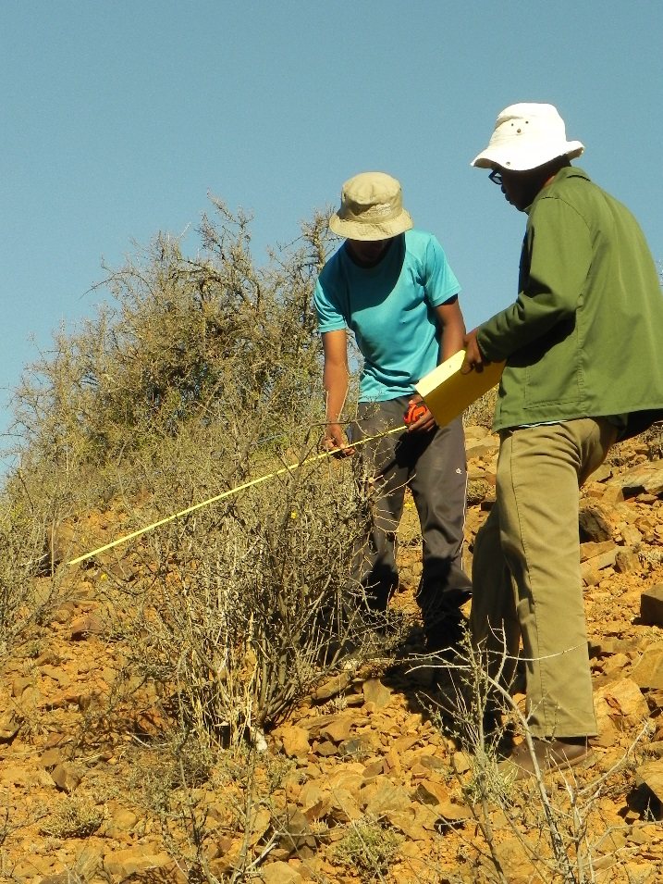

Figure 2: Above ground woody species measured for height, canopy width and canopy length, on degraded lands on Tchnuganoo.

Table 1: Below is a list of thicket species which have allometric equations based on their canopy height, length and breadth. The list is taken from data collected from Van der Vyver’s PHD work (2017).

|  |  |
| --- | --- |
| **Species name** | **Species name** |
| *Aloe striata* | *Jathropa capensis* Kirkwood |
| *Asparagus capensis* | *Lycium cinereum* Calitzdorp |
| *Azima tetracantha* | *Malephora lutea* Calitzdorp |
| *Blepharis capensis\** | *Mesembryanthemum guerichianum* |
| *Boscia oleoides* | *Panicum maximum\** |
| *Brachylaena ilicifolia* | *Pappea capensis* |
| *Capparis sepiaria* | *Portulacaria afra* |
| *Carissa haematocarpa* | *Psilocaulon junceum* |
| *Cotyledon velutina* | *Ptaeroxylon obliquum* |
| *Crassula mesembryanthemoides* | *Pteronia incana* |
| *Crassula muscosa* | *Putterlickia pyracantha* |
| *Crassula perforata* | *Rhigozum obovatum* |
| *Drosanthemum lique* | Ruschia multifloora?? |
| *Ehretia rigida* | *Schotia afra* subsp? |
| *Euclea undulata* | *Schotia afra* subsp? |
| *Euphorbia coerulescens* | *Vachellia karoo\** |
| *Euphorbia mauritanica* | *Crassula ovata\** |
| *Euphorbia triangularis* | *Lycium ferocissimum\** |
| *Galenia ??liformis* | *Pappea capensis\** |
| *Grewia robusta* | *Plumbago auriculata\** |
| *Gymnosporia polyacantha* |  |

Table 2: Below is a list of thicket species which have allometric equations based on cumulative basal stem diameter and canopy area from Powell 2009.

|  |  |  |  |
| --- | --- | --- | --- |
| **Species** | **n** | **R equation** | **R2 value** |
| *Vachellia karroo* | 15 | Log10 y (C (kg) = 2.034(**Log10 canopy area (m2**)) - 1.20113 | 0.9513 |
| *Aloe ferox* | *25* | Log10 *y* (C (kg) *= 1.4306*(**Log10 CBSA (m2**)) *+ 3.6975* | 0.7780 |
| *Crassula ovata* | 21 | Log10 y (C (kg) = 1.1337(**Log10 CBSA (m2**)) + 1.9764 | 0.9672 |
| *Ehretia rigida* | 24 | Log10 y (C (kg) = 0.9623(**Log10 CBSA (m2**)) + 2.485 | 0.6343 |
| *Euphorbia grandidens* | 25 | Log10 y (C (kg) = (**Log10 CBSA (m2**)) | 0.9249 |
| *Grewia robusta* | 37 | Log10 y (C (kg) = 1.0044(**Log10 canopy area (m2**)) – 0.6259 | 0.8502 |
| *Jatropha capensis* | 21 | Log10 y (C (kg) = 0.9067(**Log10 canopy area (m2**)) - 0.7349 | 0.5728 |
| *Lycium ferocissimum* | 35 | Log10 y (C (kg) = 0.8615(**Log10 CBSA (m2**)) + 1.7706 | 0.7676 |
| *Pappea capensis* | 22 | Log10 y (C (kg) = 1.3355(**Log10 canopy area (m2**)) + 0.1357 | 0.9265 |
| *Plumbago auriculata* | 21 | Log10 y (C (kg) = 1.0821(**Log10 CBSA (m2**)) + 2.7320 | 0.9296 |
| *Portulacaria afra* | 5 | Log10 y (C (kg) = 1.1043(**Log10 CBSA (m2**)) + 2.4464 | 0.9696 |
| *Pteronia incana* | 49 | Log10 y (C (kg) = 1.4032(**Log10 canopy area (m2**)) - 0.4224 | 0.9679 |
| *Putterlickia pyracantha* | 46 | Log10 y (C (kg) = 1.0622(**Log10 CBSA (m2**)) + 2.7834 | 0.7784 |
| *Rhus longispina* | 24 | Log10 y (C (kg) = 1.1012(**Log10 canopy area (m2**)) - 0.2938 | 0.5077 |

## *Euphorbia coerulescens* (Noors) sampling

This part of the sampling will not be changed.

1. The initial sample includes all *E. coerulescens* plants within the 10 m x 10 m permanent monitoring plot.
2. Move from one side of the plot to the other, systematically measuring each *E. coerulescens* stem in the plot.
3. Measure the height of each stem. This can be done with a metre-ruler or a pole with regular height markings inserted into the stand next to each stem.
4. Once a stem has been measured, mark it with a non-damaging marker (piece of thread, spot of paint, felt-tip marker, etc.) to prevent the double-counting of stems.
5. An alternative method of tracking counted stems is to use a rope to demarcate the stems that have already been measured, and move it to include each stem as it is counted.
6. NB: the white latex of these plants is caustic, and can irritate the skin and damage your eyes. You should avoid contact with it as much as possible, and be sure to wash your hands before eating or touching your face. It is recommended that you use heavy gloves when handling the plant.

Variables to be recorded: height of all *E. coerulescens* stems at ground level.

# Warehouse and laboratory component

## Litter analysis

This part of the sampling will not be changed.

1. Record the weight of an oven tray in the Site Record data sheet.
2. Place the litter from the plastic bag onto the oven tray.
3. Record the weight of the litter and tray (in grams, to 1 decimal place) in the Site Record data sheet.
4. Oven dry the sample at 60oC until it reaches a constant mass (see steps 5 and 6 of the carbon analysis above). Record the mass in grams, to one decimal place in the Site Record data sheet.

Variables to be recorded: Wet litter mass (g), dry litter mass (g).

# Labeling

1. Every bag should be labelled twice, with one label attached to the outside of the bag, and a loose label on the inside of the bag. Both labels for a bag must be the same.
2. The internal labels need to be durable. Ice-lolly sticks or tongue depressors would be ideal, since they can be easily marked using a felt-tip pen, and can also be placed in the oven when samples are being dried to ensure that the samples are tracked.
3. NB: REMOVE DURABLE LABELS WHENEVER MEASURING MASS OR VOLUME, AS THEY WILL SKEW THE RESULTS.

## litter samples

1. Labels always start with the plot number. Plot number will be provided in the baseline monitoring plan provided (A1.01 to A1.30)

|  |  |
| --- | --- |
| **Sample type** | **Multiple bags** |
| L = Litter | X of X |

1. An example of a litter label is **A1.25-L**. This means: Darlington Dam area, monitoring site 25, litter sample.

## Plant samples

1. Labels always start with the plot number at which the species was first identified. Plot number will be provided in the baseline monitoring plan.
2. The next part of the label is the plant form:

|  |
| --- |
| T = tree |
| Sh = shrub |
| Su = succulent |

1. Finally, assign the plant a unique count number, according to the number of species identified at the current site. Numbers should be assigned using a double digit assignment system (01, 02…, 99).
2. An example of a plant label is therefore: **A1.05-S-09**. This means: Darlington Dam area, monitoring site 5, shrub species, unidentified plant number 9.
3. Plant labels are temporary assignments, until the plant is identified correctly. Subsequently the plant will be labelled with the correct genus and species, and stored in the project herbarium.

# References

DEA NRM, 2010a. SOP for carbon and biodiversity baselines. Unpublished internal report, Department of Environmental Affairs, Natural Resource Management Chief Directorate, 14 Loop Street, Cape Town South Africa.

DEA NRM, 2010b. Working for Water Thicket Restoration Project. Project Document. Unpublished internal report, Department of Environmental Affairs, Natural Resource Management Chief Directorate, 14 Loop Street, Cape Town South Africa.

Powell, M.J. 2009. The restoration of degraded subtropical thickets in the Baviaanskloof Nature Reserve, Eastern Cape South Africa – the role of carbon stocks and *Portulacaria afra* survivorship. MSc. Thesis. Rhodes University, Grahamstown.

Van der Vyver, M. 2017. Unpublished PHD Thesis data. NMMU, Port Elizabeth.

# Annexures

# Annex 1: cARBON bASELINE monitoring datasheets

# 









1. The methodology for this project is the CDM methodology AR-AM0002 v3: . It can be downloaded from <http://cdm.unfccc.int/UserManagement/FileStorage/L1ZYHU4X5QRPFS2IVGDM8T90N3W6CJ>. However, there are a number of deviations from these equations, and consequently the Project Document should be used as a reference. The PD can be downloaded from: <http://dl.dropbox.com/u/8458610/Thicket%20project/Validation%20docs/VCS_ABFRP_PD_C4ES_05Sep2011_V3.2.pdf>
2. Available from: <http://www.spatialecology.com/htools/rndpnts.php>.